SPK623 Portable stereo speaker system
USER MANUAL

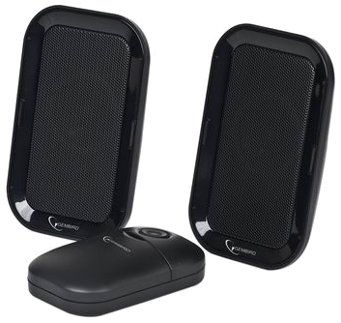

Disclaimer

- We spared no efforts to make sure that the information in this manual is correct and complete. However no liability is accepted for any errors or omissions. Gembird Electronics reserves the right to change the specifications of the hardware and software described in this manual without prior notice.
- No part of this manual may be reproduced, transmitted or translated in any language in any form, by any means, without the prior written permission of Gembird Electronics Ltd.
- Gembird Electronics makes no warranties for damages resulting from corrupted or lost data due to a mistaken operation or malfunction of the product, the software, personal computers or peripheral devices.

Gembird® is a registered trademark of Gembird Europe bv.
Other names or products not mentioned above may be registered trademarks or trademarks of their respective owners.

Copyright © 2009 Gembird Electronics Ltd. All rights reserved
Features
- Portable speaker
- Clear sound
- Magnetically shielded
- Ideal for PC, iPod, MP3/MP4 player, CD player
- Powered PC USB port or 4* AAA batteries
- PMPO 100 W

Specifications
- Channels: 2.0 (stereo)
- RMS power output: up to 2 W x 2
- Frequency response: 230 Hz - 20 kHz
- S/N ratio: > 70 dB
- Cables: 3.5 mm jack 1.2 m input audio cable
- Power supply: 5 VDC, AAA DC battery x 4 pcs or USB input, 1.2 m built-in cable
- Work time: up to 100 hrs with 1000 mAH batteries
- Dimensions (LxWxH): 80 mm x 78 mm x 120 mm
- Net weight: 0.3 kg

Package Contents
- Speakers
- Battery compartment
- Audio cable
- User manual
Introduction

Please read this manual carefully before installing and using your portable speaker system. Pay special attention to the CAUTION section of this manual.

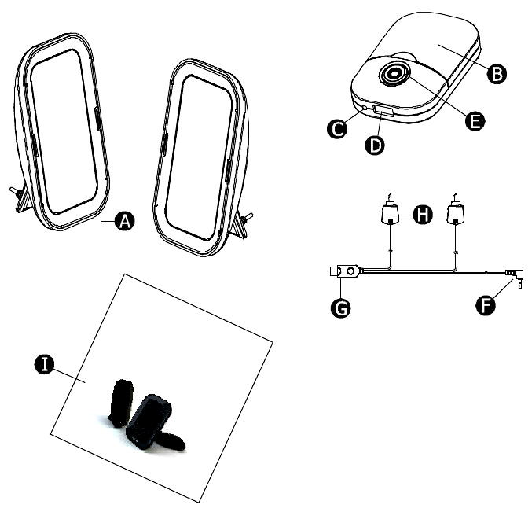
Device overview

(A) – Satellite speaker
(B) – Battery compartment
(C) – Power LED
(D) – USB socket
(E) – Power switch
(F) – Audio cable with 3,5 mm jack
(G) – USB plug
(H) – Satellite speaker connectors
(I) – User manual

Installation

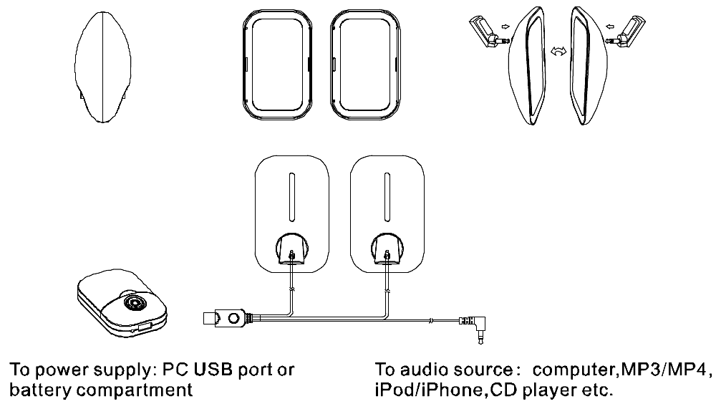

1. Separate the two speakers as shown on the picture above.
2. Connect the speakers with the cables as shown on the picture above.
3. Connect the speakers to your PC or any other external audio source, such as iPod, MP3 player, CD player with the 3.5 mm plug audio cable.
4. These speakers can be powered up either from batteries or from USB:
(I) If you wish to power the speakers from your PC - plug then the USB connector (G) into the USB port.
(II) Alternatively take the battery cover off and insert 4 pieces of AAA-size batteries into the battery compartment (B) paying attention to the polarity. Then put the battery cover back on. Plug the USB connector into the battery compartment.
5. Turn the speaker on, the power LED will light up.
6. Start music playback and adjust the volume level on your audio source.

Note: there is no volume adjustment on the speaker itself.

Troubleshooting

Problem | Solution
Power LED is not lighted | Power button is not turned on. Switch it on and check if the blue LED indicator illuminates
Power LED is not lighted | Check if batteries are inserted with correct polarity.  Replace the batteries and switch the speaker on, check if the LED illuminates
The sound cannot be heard | Verify that the speaker is getting power (see the steps above)
The sound cannot be heard | Make sure the volume is turned up to the audible level
The sound cannot be heard | Verify that all cables are plugged into the correct jacks
The sound cannot be heard | Test the speaker with another audio source. If your speaker is working well with another audio source, then the speaker is ok
Distortions | WAV and MID files are often poor quality, therefore distortion and noise are easily noticed with the powerful speakers
Distortions | Check the audio level and decrease if necessary

Caution

- Read, keep and follow these instructions.
- Keep speakers out of extreme heat and away from the sources emitting heat, such as heaters, radiators, stoves etc
- Keep speakers out of the rain and humid conditions to avoid electric shock.
- Keep speakers away from water. In order to avoid electric shock, do not let the water to drip onto the device. Do not put the water containing objects such as vases on top of the device. Do not put the device near the water.
- Do not block the openings in the speaker cabinet, never push objects into the speaker vents or slots because of fire or electric shock hazards. Provide sufficient space around the speakers for proper ventilation.
- Only use accessories supplied by the manufacturer.
- Do not use the old and new batteries together.

